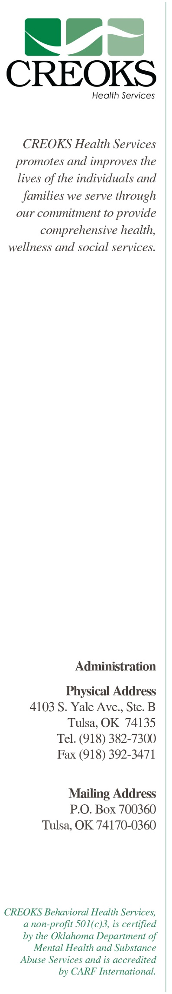

1. CREOKS will continue to seek additional funding/revenue sources through Medicare, private insurance and self-pay systems
2. CREOKS will increase substance abuse services
3. CREOKS will implement teleconference services for CEU trainings
4. CREOKS will implement a new accounting system
5. CREOKS will implement a new payroll system
6. CREOKS will continue to improve communication and trainings
7. CREOKS will transition on-site servers to cloud servers
8. CREOKS will increase outcome reports in GoHealth Solutions
9. CREOKS in increase services to veterans
10. CREOKS will develop and implement online trainings modules for Synergy
11. CREOKS will develop and implement Train the Trainer for Synergy
12. CREOKS will improve management training
13. CREOKS will prepare to become Certified Community Behavioral Health Clinics (CCBHC)
14. CREOKS will implement auditing system in GoHealth Solutions
15. CREOKS will increase fundraising
16. CREOKS will continue to remodel, improve/expand office space in Oklahoma and surrounding states
17. CREOKS will explore opportunities for diversification of funding services such as home health, physical/occupation therapy, dental, and vision
18. CREOKS will continue to provide recovery oriented, culturally competent, trauma informed and co-occurring capable services

Strategic Plan

FY 2019